CECS 524 Ada Lab

Screenshot 1 : distance from origin

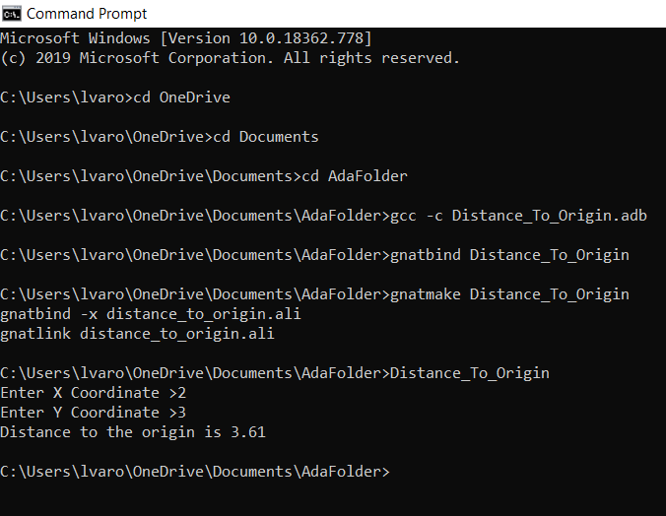

Screenshot 2 ( Distance between two points):

